14-09-2022

B2B COmmerce training aspects

The below image is the credential road map that will help developers become a B2B Commerce Professional.

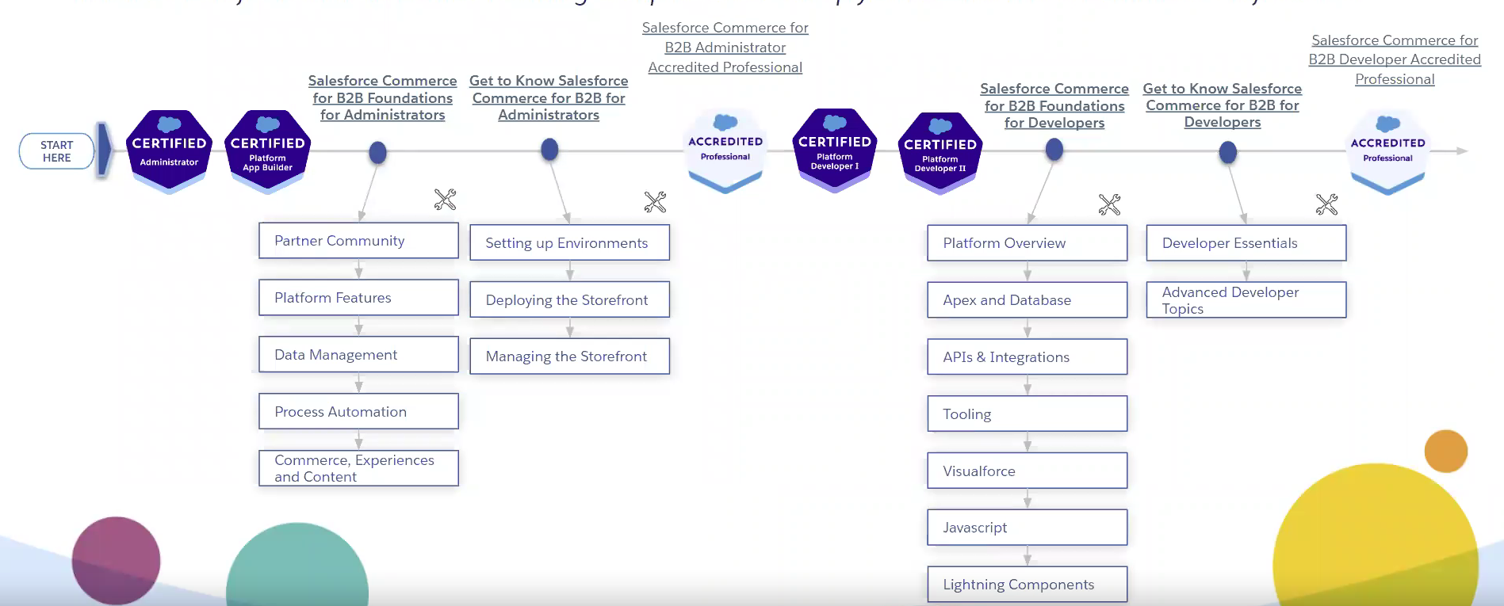

The below table lists the topics that the developer must be trained on.

| TOPIC | MODULE | Duration |  |
| --- | --- | --- | --- |
| 1. Salesforce Administration / Automation tools    1. Object and field configuration (includes explaining relationships/all field types)    2. Validation/restriction rules    3. Page layouts / lightning record pages    4. Profile and permission sets/permission set groups    5. Company information/personal information overview    6. User setup overview(creation/deactivation/freeze)    7. Email templates    8. Groups/queues    9. Custom metadata / Custom Settings /Custom labels / Custom Permissions    10. Sharing (record level, object level, field level), OWD configs    11. Roles/ Role hierarchy    12. Org Access/Security policies/restricting login    13. Lightning tabs configuration    14. Translation’s workbench    15. Support process/ Sales Process    16. Dashboards /Reports    17. Lighting app builder    18. Case assignment / Lead assignment rules    19. Lead field mappings to other standard objects    20. Omni Channel configuration (not necessary but good to have)    21. Platform events    22. Static resources | SALESFORCE ADMINISTRATION |  |  |
| 1. Process Automation Tools    1. Flows, flows with sub flows (Record triggered, screen flows, platform event triggered etc.)    2. Approval Process    3. Workflow rules/Actions | DEVELOPMENT USING SALESFORCE AUTOMATIONS |  |  |
| 1. Commerce Administration    1. B2B Data Model Overview    2. Setting up a store       1. Enabling commerce, Digital Experiences, CMS, order preferences.       2. Update page layouts       3. Configuration of sharing settings       4. Update Record pages, home pages to add buyer information and new tabs.       5. Permissions sets for buyer, buyer manager, account switcher       6. Installation of reports       7. Create a store via commerce app with OOTB template       8. Full store administration (Buyer Access, Overview of checkout flow, guest buyer access, Localization, Pricing)       9. Sample data setup and assigning them to store (assign catalogs, buyer groups, price books, search index overview    3. CMS/Workspace/Builder configurations       1. Creation of CMS workspaces       2. Load sample content into CMS       3. Experience builder Overview       4. Builder administration branding, Login/Registration link up with published community pages       5. Allow self-registration       6. Email configurations-welcome, forgot password etc.       7. Customize pages in builder with point and click tools.       8. Customize Product detail pages, navigation menu, support pages.       9. Page variations/ Audience management.       10. Navigation, Languages, Google analytics, security and privacy overview.       11. Builder Components overview (CMS collections, Tile Menu , Tabs , analytics and commerce components etc.)       12. Content Management-content, collections, topics, Recommendations, Recommendation carousels.       13. Product import using csv       14. Account switcher    4. Promotions, Pricing, Products, Store Inventory, Payment gateway , tax & shipping calculation integration links with sample apex classes.    5. Setup of accounts, contacts, enablement as buyers to login to experience as user.    6. Deployment through change set | COMMERCE ADMINISTRATION |  |  |
| 1. Triggers / Apex / LWC / Aura (basic)    1. Trigger framework and best practices    2. Synchronous / Asynchronous Apex / Best practices       1. With/Without sharing apex classes       2. SOQL/SOSL Queries       3. Batch classes       4. Queueable classes       5. Schedulable classes       6. Integration Overview in Apex       7. Test Classes with test data factory structure.       8. Connect API methods for B2B commerce overview       9. Best Practices    3. LWC       1. Component Lifecycle Hooks(constructor, connected callbacks, etc.)       2. Basic overview of HTML       3. Lightning design system usage in HTML       4. CSS (basic overview)       5. JavaScript variables, datatypes, functions and built-in functions.       6. Data Binding       7. Lightning data service       8. Building reusable components and component composition.       9. Component communication using Pub sub/LMS/Events.       10. Target configurations / Properties (Design attributes)       11. Record Forms       12. Imperative/ Wire Methods       13. Lightning locker service overview       14. Navigation / Quick,Screen Actions   5. LWR Template | DEVELOPMENT USING CUSTOM CODE |  |  |
|  |  |  |  |
|  |  |  |  |
|  |  |  |  |
|  |  |  |  |
|  |  |  |  |
|  |  |  |  |
|  |  |  |  |
|  |  |  |  |
|  |  |  |  |
|  |  |  |  |